**Ideation Phase**

**Define the Problem Statements**

|  |  |
| --- | --- |
| Date | 17 June 2025 |
| Team ID | LTVIP2025TMID59024 |
| Project Name | Flight Finder |
| Maximum Marks | 2 Marks |

**Customer Problem Statement Template:**

To define the core problems faced by users and restaurant owners in local food ordering scenarios, and use those insights to guide the development of *Flight Finder.*

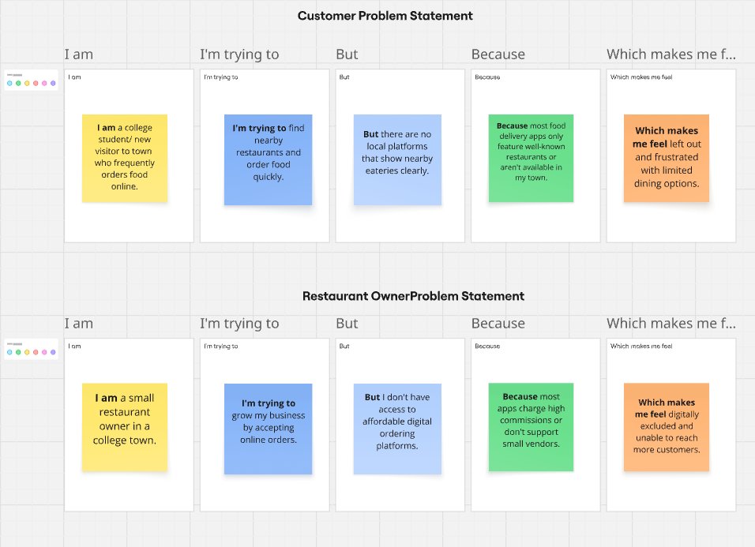

Link : https://miro.com/app/board/uXjVIj4I_7c=/?share_link_id=867770432634

Reference: <https://miro.com/templates/customer-problem-statement/>

|  |  |  |  |  |  |
| --- | --- | --- | --- | --- | --- |
| **Problem Statement (PS)** | **I am (Customer)** | **I’m trying to** | **But** | **Because** | **Which makes me feel** |
| PS-1 | **I am a student or traveler** trying to plan a trip or return home. | find affordable and suitable flights based on my preferences | I cannot easily compare all flight options in one place | most airline websites and platforms show limited or biased results | left out, with limited choices |
| PS-2 | **a frequent flyer or business traveler** with tight schedules | quickly book flights that match my time and budget | I waste time switching between multiple apps and websites | current systems lack centralized, intuitive search features | overwhelmed and time-constrained |